**Building Java Project in Azure DevOps using Self Hosted Agent**

* Azure Pipeline yaml schema <https://learn.microsoft.com/en-us/azure/devops/pipelines/yaml-schema/?view=azure-pipelines>
* Task in Azure DevOps Pipelines: Tasks internally get converted in low level os commands/api calls.
* Azure DevOps has lot of predefined tasks <https://learn.microsoft.com/en-us/azure/devops/pipelines/tasks/reference/?view=azure-pipelines>
* We can also get additional tasks from Market <https://marketplace.visualstudio.com/azuredevops>
* Lets acheive building the code without using any task.
* Manual command is mvn package
* The pipeline is

# Starter pipeline

# Start with a minimal pipeline that you can customize to build and deploy your code.

# Add steps that build, run tests, deploy, and more:

# https://aka.ms/yaml

trigger:

- main

pool:

name: Default

steps:

- bash: mvn package

* Push the changes and build should start (trigger)  
  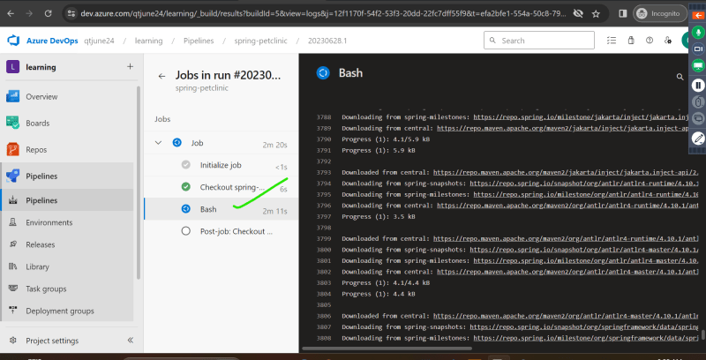
* Let’s try using tasks for maven <https://learn.microsoft.com/en-us/azure/devops/pipelines/tasks/reference/maven-v4?view=azure-pipelines>

# Starter pipeline

# Start with a minimal pipeline that you can customize to build and deploy your code.

# Add steps that build, run tests, deploy, and more:

# https://aka.ms/yaml

trigger:

- main

pool:

name: Default

steps:

- task: Maven@3

inputs:

mavenPOMFile: 'pom.xml'

goals: 'package'

publishJUnitResults: true

testResultsFiles: '**/surefire-reports/TEST-*.xml'

testRunTitle: 'unittests'

* Now push the changes and wait for pipeline getting executed

**Build pipeline for dotnet project**

* Manual steps:
  + Install .net 7
  + clone nop commerce and checkout to master branch
  + commands  
    yaml  
    git checkout master  
    dotnet restore src/NopCommerce.sln  
    dotnet build src/NopCommerce.sln
* Find tasks to perform restore and build and fill with the values required to build this project google azure devops task list
* The pipeline will be approximately equavalent to

---

trigger:

- master

pool:

name: Default

steps:

- task: DotNetCoreCLI@2

inputs:

command: restore

projects: src/NopCommerce.sln

- task: DotNetCoreCLI@2

inputs:

command: build

projects: src/NopCommerce.sln